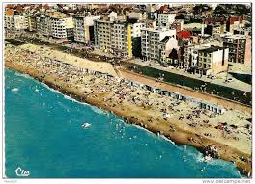
www.flabasevents.com
flabasevents@gmail.com
(0032)(0)473 37 39 66
Belgian Coast Challenge 2023
May 20/21
U10/U12/U14 (mixed)
To all team managers and coaches,
It’s with much pleasure that we can invite you to our traditional two days Spring tournament “The Belgian Coast Challenge” for U10/U12/U14 teams in Koksijde at the Belgian Coast.
During two days your team can enjoy fantastic basketball games, the sea, the beach and the beautiful dunes.
Games will be held in two gyms of the city (Koksijde-dorp and Oostduinkerke). Lodging and evening meal is possible in youth hostel De Peerdevisser in Oostduinkerke. You need to have your own transport.
Every team plays 5 adapted games (3 on Saturday and 2 on Sunday). In the past we had teams from all over Belgium, but also from Holland, France, England and Germany.
Every team needs to buy at least 9 tournament passes. The pass for the coach and 12th. player is for free.
A pass costs 25 euros and comes with :
- an original tournament T-shirt
- A tournament medal
- A nice trophy for the team
- A practical basketball gift for the coach

Lodging and meals
Lodging is possible in the youth hostel De Peerdevisser in Oostduinkerke. Ask us for information, prices and reservations.
Hot meals can also be obtained in the youth hostel or even in de restaurant of the sports hall in Oostduinkerke. Ask us for all information.
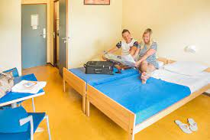
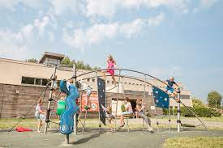

Inscription form Belgian Coast Challenge
To : flabasevents@gmail.com

Club : ………………………………………………………………………………………………
Correspondent : ……………………………………………………………………………………………
e-mail : …………………………………………………………………………………………………………
mobile : ……………………………………………………………………………………………………………
Participates with :
O U10
Number of players exact can be communicated before april 15th. : ………….
Manager present : ……………………………………………………………………………….
mobile : …………………………………………………………………………………..
O U12
Number of players exact can be communicated before april 15th. : ………….
Manager present : ……………………………………………………………………………….
mobile : …………………………………………………………………………………..
O U14
Number of players exact can be communicated before april 15th. : ………….
Manager present : ……………………………………………………………………………….
mobile : …………………………………………………………………………………..

